

Supporting people with sight loss in Essex

**SIGHTLINE**

**Winter 2023**

**Season’s Greetings from Support 4 Sight**

Support 4 Sight mugs and information card with

Christmas items made by the Chelmsford Craft Group

**Tribute to Graham Hawkes**

# 05/02/1960 – 12/10/2023



Photo of Graham Hawkes

Support 4 Sight, its staff, trustees, volunteers and members of our community are deeply saddened by the passing of our friend and colleague Graham Hawkes, who died unexpectedly, after a short illness, on 12.10.2023.

Graham was the face and heart of Support 4 Sight, our front man, our wing man, who understood, through his own experience, how vitally important support and social interaction is when living and coping with sight loss.

Graham established coffee mornings, the Chelmsford Centre, and a whole host of social activities, unlike anything else on offer across the region. He was always looking for the next opportunity for our members, from Cockney Knees-Ups to boat trips and evermore adventurous weekends away, alongside introductions to gadgets and apps to transform everyday living.

He was determined that people should have the support and opportunity they needed, and his can-do approach achieved just that. We would often hear *after* an event how it very nearly didn’t happen because of one thing or another, which Graham had managed to remedy so that all went ahead as planned, with no mention of all the paddling under water that he had done to make it so ‘seamless’.

He fronted many a quiz evening, with humour and generosity, and was a role model to many in his journey from service user to member of staff.

To say he will be missed is an understatement. We will miss him every day. And we will strive to maintain the services he established as a fitting and lasting testament to his ambition for our community.

Photo of Graham Hawkes

# That was the year that was

2023 has continued to bring a growing level of need.

This is reflected in our client assessments, done at 3-6 month intervals, which show a significant decrease in health, emotional wellbeing, choice and control, and financial wellbeing outcomes.

Picture of chart showing assessment results

However, the responses to our Autumn Survey show the levels of impact our services have made in addressing these needs.

1. 90% said we made a difference to their Emotional Wellbeing
2. 86% to their Social Inclusion
3. 76% to their Choice & Control (Independence)
4. 66% to Understanding their Eye Condition (Health)
5. 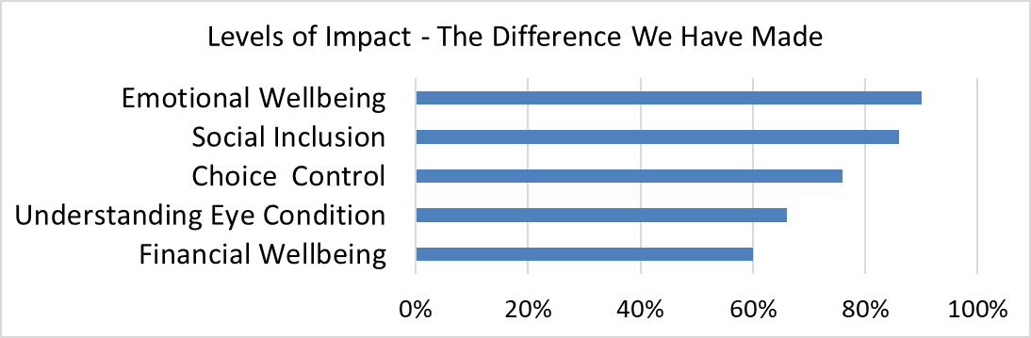60% to their Financial Wellbeing

Picture of chart showing the levels of impact

# Looking Forward… To 2024

Following the feedback from our Autumn Survey we are looking to provide further opportunities to socialise, access demonstrations of assistive equipment and technology, and support people to gain the skills and confidence to maximise digital opportunities.

With 2023 coming to a close, here are the plans for 2024.

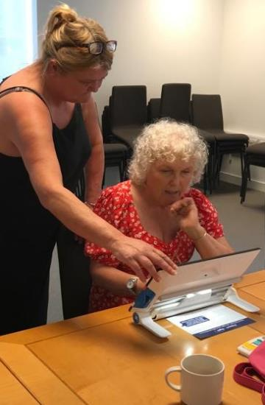

**MOWS (Moving On With Sight-Loss)** – Following on from the success of our MOWS sessions in 2023, we’ll be bringing them back to provide more people with information about registration, services, equipment and tech demonstrations.

**S4S Active** – Feedback from our initial walking group and armchair exercise sessions has been very positive. If your New Year goal is to get more active, from January you can join either our walking groups or armchair exercise sessions in Chelmsford or Saffron Walden.

Sue demonstrating an electronic magnifier

**Technology** – Our goal is to round out our tech offer and bring this to each of the areas we cover. This will include information and support for electronic magnifiers, phones, tablets, laptops, computers and smart home devices.

For more information on any of these services please call us on 01245 933572 or on <info@support4sight.org.uk>

**Support 4 Employment** - If you are of working age and need help with finding, retaining or preparing for work, this award winning service is there to support you. Call 07950 945119 or email [zsuzsanna@support4sight.org.uk](mailto:zsuzsanna@support4sight.org.uk)

# Social Calendar

## Christmas Party!!!

Our hugely popular Christmas party will this year be held on Wednesday 20th December at Broomfield Village Hall, Chelmsford, CM1 7AH from 12 noon – 3pm. With food refreshments and entertainment from The Ladybirds and a Christmas Hamper Raffle. Cost £10.

Champagne glasses

Please contact ASAP on 01245 933572 to reserve your place.

## Clubs

* **Braintree Supper Club** - Held at various eateries around Braintree. To join the club, contact Sue on 01245 933572.
* **Chelmsford Lunch Club** - Held at various eateries in central Chelmsford. Please call 01245 933572 for details

## S4S Active

With the New Year coming up, what better time to take part!

* **Chelmsford Walking Group** - Cottage Place on the second Wednesday of the month at 11am. Dates: 10 Jan, 14 Feb, 13 Mar.
* **Chelmsford Seated Exercise** – Broomfield Village Hall at 11am. Dates: 17 Jan, 21 Feb, 20 Mar.
* **Saffron Walden Walking Group** – Community Link on the first Tuesday of the month at 11am. Dates: 6 Feb, 12 Mar.
* **Saffron Walden Seated Exercise** – Bowls Club on the last Tuesday of the month at 11am. Dates: 30 Jan, 27 Feb, 26 Mar.

## Rainbow Online Social Group

2nd and 4th Thursday of the month from 10 to 11am on the following link: <https://us02web.zoom.us/j/4580437872>

## WAVE (Working Age Vision Essex)

An informal online group for working age people. 1st Thursday of each month at 6 to 7.30pm: <https://us06web.zoom.us/j/6469081170>

# **Coffee Club/Roaming Resource Centre**

Join us for a tea, coffee, and a look at assistive equipment.

If you have any queries about the clubs, equipment demonstrations or how to get to the venues, call 01245 933572.

**Takeley** –Last Friday of the month, 10.30am until noon at The Old School Community Café, Dunmow Road, Takeley, CM22 6SB. Dates: 22 Dec, 26 Jan, 23 Feb.

**Chelmsford** – First and Third Wednesday of the month, 10:30am until 1:45pm at Broomfield Village Hall, 158 Main Rd, CM1 7AH. Dates: 6 Dec, 20 Dec (Party, details on page 6), 3 Jan, 17 Jan, 7 Feb, 21 Feb, 6 Mar, 20 Mar.

**Braintree** –First Monday of the month, 10:30 until noon (except on Bank Holidays). The Yumy Café, 8 Little Square, Braintree CM7 1UT. Dates**:** 4 Dec, 5 Feb, 4 Mar.

**Epping** - Second Monday in the month, 10.30am until noon, at Epping Library, St Johns Road, Epping, CM16 5DN. Dates: 11 Dec, 8 Jan, 12 Feb, 11 Mar.

**Harlow** -Second Tuesday of the month, 10.30am until noon at the Potter Street Baptist Church ‘Coffee Stop‘, 98 Potter Street, CM17 9AW. Dates: 12 Dec, 9 Jan, 13 Feb, 12 Mar.

**Saffron Walden**

* Community Link**,** 1B Market St, CB10 1HX. First Tuesday of the month. 9:30am until 11:45am Dates: 5 Dec, 6 Feb, 12 Mar.
* Bowls Club**,** Abbey Lane, CB10 1DG.Last Tuesday of the month, 10:30-noon. Dates: 19 Dec, 30 Jan, 27 Feb, 26 Mar.

**Witham** -First Thursday of the month 10.30am until noon at Witham Hub, 17 The Grove Shopping Centre, Witham, CM8 2YT.

Dates: 7 Dec, 4 Jan, 1 Feb, 7 Mar.

Please note: Irregular December dates for Saffron Walden Community Link

# OrCam Read Smart. Orcam Read is a highly sophisticated lightweight smart camera. Using AI technology, it instantly reads any printed or digital text from books, newspapers, smartphone screens, computers and more. It is intuitively operated, with just the press of a button. Either listen via the mini speaker on the device or through headphones (wired or Bluetooth). Orcam Read is the most efficient smart pen on the market, with Speed Reading and the only one with Full Page Capture. It is designed for all ages and does not require and internet connection. Perfect for those at home, work and school. Great for those with moderate low vision, reading difficulties, including dyslexia and reading fatigue. Sale Price £1800 RRP £2000 Includes FREE Bluetooth headphones As seen on TV Freephone 0800 145 6115 For a FREE home demonstration or for more information.Advert from Optelec

OrCam Read Smart.

OrCam Read is a highly sophisticated lightweight smart camera. Using AI technology, it instantly reads any printed or digital text from books, newspapers, smartphone screens, computers and more. It is intuitively operated, with just the press of a button. Either listen via the mini speaker on the device or through headphones (wired or Bluetooth). OrCam Read is the most efficient smart pen on the market, with Speed Reading and the only one with Full Page Capture. It is designed for all ages and does not require and internet connection.

Perfect for those at home, work and school. Great for those with moderate low vision, reading difficulties, including dyslexia and reading fatigue.

Sale Price £1800

RRP £2000

Includes FREE Bluetooth headphones

As seen on TV

Freephone 0800 145 6115 For a FREE home demonstration or for more information.

# The Quirky 30 Challenge teaser:

# Leah’s 30 Xmas Jumpers

2024 is Support 4 Sight’s 30th Anniversary!

To mark this we shall be launching the Quirky 30 Challenge.

Inspired by Leah Jackman who has decided to prolong the Christmas cheer by wearing 30 Christmas outfits throughout June 2024.



We shall be looking at supporting a different 30 challenge each month.

It could be:

* selling 30 cupcakes to willing friends with a sweet tooth
* walking 30 laps of your local park
* giving up coffee for 30 days

As long as it’s related to 30, anything’s possible!

Please let us know what your Quirky 30 is!

Photo of Leah dressed in a Christmas outfit holding a 3 and a 0 balloon

Call us on 01245 933572 or email <info@support4sight.org.uk>

Watch this space and our website/social media for the full calendar along with ways to sponsor our Quirky 30 Challenges.

# Launch of the

# Eye Care Support Pathway

# by Sharon Schaffer

I was delighted to be at the launch of the Eye Care Support Pathway on 16th November.

This is a major collaboration between organisations across the breadth of the eye health and sight loss sector, including Visionary, representing local sight loss charities like us at Support 4 Sight.

The Eye Care Support Pathway is a person centred pathway that those involved in delivering, planning and commissioning eye care services can now use as a benchmark for their work of service transformation.

This is exactly what we were working towards in my England Vision Strategy days. I remain, as always, hopeful.

For more information on the Pathway, please visit: <https://www.rnib.org.uk/your-eyes/the-eye-care-support-pathway/>

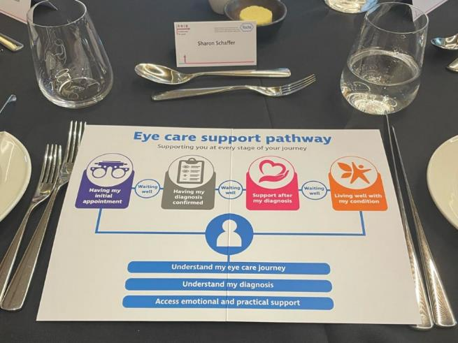

Photo: my place setting at the launch lunch with a graphic of the Eye Care Support Pathway at the Centre

# A line of colorful dots Description automatically generatedA line of colorful dots Description automatically generatedA gold box with red ribbon Description automatically generatedA gold box with red ribbon Description automatically generatedSupport 4 Sight Logo

# Christmas Appeal 2024

**We are always grateful for donations to help us continue providing our services. This Christmas please support us however you are able.**

If you’re still doing your Christmas shopping please consider:

**Give As You Live -** When shopping online, this donates a small sum to S4S for every transaction at no cost to you.

<https://www.giveasyoulive.com/charity/support-4-sight>

**Amazon Wishlist -** For those wishing to make a direct contribution. Any wishlist item can be added to your cart and sent directly to us by adding our address in the delivery box.

<https://amzn.eu/dbXoWT9>

**Standing order** – a regular donation will help us plan ahead to structure our services and activities, please call 01799 588897

**Debit/Credit card** – please call us on 01245 933572 or 01799 588897

**Online** - via the Donate button on our website:

[www.support4sight.org.uk/](https://www.support4sight.org.uk/)

**CAF Donate -** at [cafdonate.cafonline.org/9007](https://cafdonate.cafonline.org/9007)

**By Cheque** - made out to Support 4 Sight, and posted to Support 4 Sight, 17 Cottage Place, Chelmsford, CM1 1NL

Please contact us with any queries on 01799 588897

Email: [info@support4sight.org.uk](mailto:info@support4sight.org.uk)

**Your donation makes all the difference. Thank you!**

# A pair of gold bells with red berries Description automatically generatedChristmas closure

Office closed Sat 23 December – Mon 1 January.

Last workday Fri 22 December and back on Tue 2 January

**Contact Us:**

**01799 588897 or 01245 933572**

[Info@support4sight.org.uk](mailto:Info@support4sight.org.uk)

17 Cottage Place, Chelmsford, Essex, CM1 1NL

[www.support4sight.org.uk](http://www.support4sight.org.uk)

**Feedback:** We welcome feedback on this magazine and all our services. Your opinion really does help us to shape the charity and the services we deliver, so please get in touch with us and share your thoughts.

If you wish to receive this newsletter in an alternative format or to unsubscribe from future editions of Sightline, please contact us to help us keep your preferences up to date.

All information in this Newsletter is checked and believed to be correct at the time of publication, but cannot be so guaranteed. Support 4 Sight shall not be liable for any loss suffered directly or indirectly as a result of its use.



Registered Charity No. 1169324

Supported by

****